This next circuit uses diodes and capacitors to level out an AC sine wave to approximate a DC source. First the diode connected to the positive terminal of the power supply makes the current only move in one direction creating times of source current and times of no source current. During the time of source current the 1µF capacitor stores voltage when then when the time of no source current capacitor discharges creating a more level voltage source. The final component to this circuit is the zener diode.

The zener diode is like a pressure valve if the voltage gets too high the diode breaks down. This keeps the voltage across the load constant approximately around its breakdown voltage.

When we lower the load resistance the voltage across the Load decreases. The zener diode connected in parallel with the load also decreases. If this voltage drops below the breakdown voltage the voltage across the load will not be the breakdown voltage.

When we increase the frequency of the source to 1000 Hz, the output voltage levels out to the breakdown voltage of the zener diode. The voltage across the load using an ordinary dc volt meter givies us 7.12 Volts. the data sheet supplied to us shows the breakdown voltage is around 7.5 volts. the oscilloscope measures the mean voltage across the load is 7.20V. The value the DC voltmeter gives us is 5% different then the data sheet and 1% different then the oscilloscope mean value. This may just be due to the internal resistance of the meter.

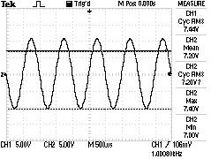

notes: i don't think we did this part right. we were supposed to set the input wave at 115 rmf. then we would see the voltage across the load is the breakdown voltage of the zener diode.